**Real-Estate Website**

**Software Requirements Specification**

**INT219**

**FRONTEND WEB DEVELOPER**

**Dhanshree Saini – 12303784**

**Sweety Pradhan – 12305083**

**Janhvi Gupta – 12310598**

**Siddhant Patel - 12301202**

Prepared for

Continuous Assessment 3

Spring 2025

**Table of Contents**

Revision History ii

1. Introduction 1

1.1 Purpose 1

1.2 Scope 1

1.3 Definitions, Acronyms, and Abbreviations 1

1.4 References 1

1.5 Overview 1

2. General Description 2

2.1 Product Perspective 2

2.2 Product Functions 2

2.3 User Characteristics 2

2.4 General Constraints 2

2.5 Assumptions and Dependencies 2

3. Specific Requirements 2

3.1 External Interface Requirements 3

3.1.1 User Interfaces 3

3.1.2 Hardware Interfaces 3

3.1.3 Software Interfaces 3

3.1.4 Communications Interfaces 3

3.2 Functional Requirements 3

3.2.1 <Functional Requirement or Feature #1> 3

3.2.2 <Functional Requirement or Feature #2> 3

3.5 Non-Functional Requirements 3

3.5.1 Performance 3

3.5.2 Reliability 3

3.5.3 Availability 3

3.5.4 Security 3

3.5.5 Maintainability 3

3.5.6 Portability 3

3.7 Design Constraints 3

3.9 Other Requirements 3

4. Analysis Models 4

4.1 Data Flow Diagrams (DFD) 4

5. Github link…………………………………………………………………………………………………….5

**6. DEPLOYED LINK………………………………………………………………………………………………...6**

7. CLIENT APPROVAL PROOF……………..…………………………………………………………………….7

**8. CLIENT LOCATION PROOF……………………………………………………………………………………8**

**9. TRANSACTION ID PROOF……………………………………………………………………………………...9**

**10. EMAIL ACKNOWLEDGEMENT…………………………………………………………………………….10**

**11. GST No…………………………………………………………………………………………………………...11**

A. Appendices

A.1 Appendix 1

A.2 Appendix 2

# 1. Introduction

The introduction to the Software Requirement Specification (SRS) document should provide an overview of the complete SRS document. While writing this document please remember that this document should contain all of the information needed by a software engineer to adequately design and implement the software product described by the requirements listed in this document. (Note: the following subsection annotates are largely taken from the IEEE Guide to SRS).

## 1.1 Purpose

## This document outlines the software requirements for a real estate website that enables property browsing, buying, selling, and management. It serves as a comprehensive guide for developers, designers, and stakeholders involved in the project.

## 1.2 Scope

**1. Software Product Identification**

**Product Name**: RealEstate Web Platform

**2. Product Overview**

The RealEstate Web Platform is a web application that facilitates real estate activities such as property listing, user registration, appointment scheduling, and online payments. It provides role-specific features for both buyers and sellers.

The platform will:

* Support property listing, editing, and image uploads by sellers.
* Allow buyers to search properties and schedule visits.
* Handle secure registration, login, and user sessions.
* Enable appointment management and online payments.

The platform will not:

* Mediate legal aspects of transactions.
* Provide physical assistance or property verification.

**3. Application of the Software**

**(a) Objectives and Benefits**

* Enable easy listing and searching of properties**.**
* Provide role-based dashboards for buyers and sellers**.**
* Support real-time appointment scheduling.
* Enhance user experience with a responsive, intuitive UI.

**(b)** **Alignment with Higher-Level Specs**

The product scope aligns with system-level requirements to offer a secure, user-friendly platform for managing real estate transactions online.

## 1.3 Definitions, Acronyms, and Abbreviations

1. **SRS -** Software Requirements Specification – A document that describes the software system to be developed.
2. **UI -** User Interface – The space where users interact with the website (e.g., forms, buttons, navigation).
3. **UX -** User Experience – The overall experience a user has while interacting with the website.
4. **HTML -** HyperText Markup Language – The standard language for creating web pages and structuring content.
5. **CSS -** Cascading Style Sheets – A language used to describe the presentation of HTML elements.
6. **Tailwind CSS -** A utility-first CSS framework used for designing responsive and modern user interfaces.
7. **JS -** JavaScript – A scripting language used to create dynamic content and handle client-side logic.
8. **PHP -** Hypertext Preprocessor – A server-side scripting language used for handling backend operations.
9. **MySQL -** A relational database management system used to store and manage the application's data.
10. **DBMS -** Database Management System – Software used to store, retrieve, and manage data (e.g., MySQL).
11. **API -** Application Programming Interface – A set of protocols that allows different software systems to communicate.
12. **Session -** A server-side storage of user data to maintain state between HTTP requests (e.g., login sessions).
13. **Role-based Access** - A system that provides different access levels and functionality depending on user roles (e.g., buyer, seller).

## 1.4 References

|  |  |  |  |  |
| --- | --- | --- | --- | --- |
| Ref No. | Title | Date | Publishing Organization | Source/Access |
| 1 | IEEE Std 830-1998: IEEE Recommended Practice for Software Requirements Specifications | 1998 | IEEE (Institute of Electrical and Electronics Engineers) | <https://ieeexplore.ieee.org/document/720574> |
| 2 | PHP Manual | Current | The PHP Group | <https://www.php.net/manual/en/> |
| 3 | MySQL Documentation | Current | Oracle Corporation | <https://dev.mysql.com/doc/> |
| 4 | Tailwind CSS Documentation | Current | Tailwind Labs Inc. | <https://tailwindcss.com/docs> |
| 5 | W3C HTML and CSS Standards | Current | World Wide Web Consortium (W3C) | <https://www.w3.org/standards/> |
| 6 | MDN Web Docs: HTML, CSS, and JavaScript | Current | Mozilla Foundation | <https://developer.mozilla.org/> |

## 1.5 Overview

This Software Requirements Specification (SRS) outlines the functional and non-functional requirements for the RealEstate Web Platform. The document serves as a comprehensive guide for developers, designers, testers, and stakeholders involved in the development of the system*.*

# 2. General Description

This section of the SRS should describe the general factors that affect 'the product and its requirements. It should be made clear that this section does not state specific requirements; it only makes those requirements easier to understand.

## 2.1 Product Perspective

The real estate website is a standalone web application that integrates with a MySQL database for data storage and management. It operates within the XAMPP environment, utilizing Apache as the web server.

## 2.2 Product Functions

The RealEstate Web Platform will perform the following key functions:

* **User Registration & Login**: Secure account creation and authentication for buyers and sellers.
* **Property Listing Management**: Sellers can add, update, and manage property listings with images.
* **Property Search**: Buyers can search and filter properties based on various criteria.
* **Appointment Scheduling**: Users can book and manage property visit appointments.
* **Role-Based Dashboards**: Custom interfaces and features based on user roles.

## 2.3 User Characteristics

The users of the RealEstate Web Platform include:

* **Buyers**: Individuals looking to browse, search, and schedule visits for listed properties. Most users will have basic internet and mobile device literacy.
* **Sellers**: Property owners or agents who manage listings, respond to inquiries, and handle appointments. They are expected to have moderate digital proficiency*.*

## 2.4 General Constraints

* **Technology Stack**: The system must be developed using **HTML**, **Tailwind CSS**, **JavaScript**, **PHP**, and **MySQL**.
* **Hosting Environment**: The application must be compatible with **Apache server** and **XAMPP** for local development.
* **Database**: Only **MySQL** will be used for data storage and retrieval.
* **Browser Compatibility**: The platform must support modern web browsers (e.g., Chrome, Firefox, Safari, Edge).
* **Security**: User authentication and data handling must follow standard web security practices.
* **Responsive Design**: The UI must be responsive and mobile-friendly.
* **Performance**: The system should handle moderate traffic efficiently without significant delays.

## 2.5 Assumptions and Dependencies

* **Assumptions**:

1. The platform will be hosted on a server with **PHP**, **MySQL**, and **Apache** support.
2. Users will have access to modern web browsers (e.g., Chrome, Firefox, Safari) and stable internet connections.
3. The system will be used primarily by users with basic internet and device knowledge.

* **Dependencies**:

1. **Third-party APIs**: The platform may depend on external APIs for location-based services, climate data, or property verification.
2. **Web Hosting**: The software is dependent on the availability of appropriate hosting environments and server configurations.
3. **Security Standards**: The platform relies on up-to-date encryption and security protocols for data protection.

# 3. Specific Requirements

The following section outlines the detailed requirements for the RealEstate Web Platform. Each requirement is organized to provide clarity and traceability for the software design, implementation, and testing.

## 3.1 External Interface Requirements

### 3.1.1 User Interfaces

* The platform will have a **responsive user interface** that adapts to both desktop and mobile devices.
* **UI Design**: The user interface will be clean, modern, and intuitive, using **Tailwind CSS** for layout and styling.
* **Login/Registration**: Users will be able to sign up, log in, and manage profiles through a secure authentication system.
* **Property Listing Pages**: Users (buyers and sellers) will have access to property details, images, and other relevant information.
* **Appointment Scheduling**: Users will be able to schedule and manage property visits through an integrated calendar system.

### 3.1.2 Hardware Interfaces

* The platform will be designed to run on **web servers** capable of supporting **PHP** and **MySQL**.
* Users will access the platform via **web browsers** (Chrome, Firefox, Safari, Edge) on **desktop and mobile devices**.

### 3.1.3 Software Interfaces

* **Database**: The system will interact with a **MySQL** database to store user data, property listings, appointments, and payment transactions.
* **Payment Gateway**: The system will integrate with external **payment gateways** (e.g., PayPal, Stripe) for secure transaction processing.

### 3.1.4 Communications Interfaces

* The platform will communicate with external APIs to fetch **climate data** and **location-based services** (e.g., Google Maps API).
* Email notifications will be sent to users for **appointment confirmations** and **new property listings**

## 3.2 Functional Requirements

### 3.2.1 User Registration and Login

3.2.1.1 Introduction - The system must allow users (buyers and sellers) to create accounts and log in securely.

3.2.1.2 Inputs - User information (name, email, password) for registration.

3.2.1.3 Processing - The system will validate user credentials and store account data in the **MySQL** database.

3.2.1.4 Outputs - Confirmation emails upon successful registration.

3.2.1.5 Error Handling - Display error messages for invalid input (e.g., incorrect password, missing fields).

### 3.2.2 Property Listing Management

3.2.2.1 Introduction - Sellers should be able to list properties, update details, and upload images.

3.2.2.2 Inputs - Property details (location, price, description) and image files.

3.2.2.3 Processing - The system will process and store the property data in the database and display it on the listing page.

3.2.2.4 Outputs - A published property listing visible to all users.

3.2.2.5 Error Handling - Error messages for incomplete fields or invalid image formats.

**3.2.3 Appointment Scheduling**

3.2.3.1 Introduction - Users can schedule property visits.

3.2.3.2 Inputs - Date and time selection for appointments.

3.2.3.3 Processing - The system will check availability and store the appointment data in the database.

3.2.3.4 Outputs - Confirmation of scheduled appointment with date, time, and property details.

3.2.3.5 Error Handling - Error messages for double-booked slots or invalid time entries.

## 3.5 Non-Functional Requirements

### 3.5.1 Performance

The system should load property listings within **2 seconds**.

### 3.5.2 Reliability

**99.9% uptime** during normal operation.

### 3.5.3 Availability

The platform should be available **24/7**, except during scheduled maintenance.

### 3.5.4 Security

All user data must be encrypted in transit using **SSL/TLS**.

**Password hashing** and **secure session management** should be implemented for authentication.

### 3.5.5 Maintainability

The system should allow for easy updates to property listings and user accounts via a clean admin interface.

### 3.5.6 Portability

The platform must be able to run on standard **Linux-based** web hosting environments.

## 3.7 Design Constraints

* The platform must be developed using the specified tech stack: **HTML**, **Tailwind CSS**, **JavaScript**, **PHP**, and **MySQL**.
* The design must be compatible with **mobile-first** development to ensure usability on all devices.

## 3.9 Other Requirements

* **Internationalization (I18N)**: Future versions of the platform should support multiple languages for broader geographic reach.
* **Accessibility**: The platform must meet **WCAG 2.0** accessibility standards for users with disabilities.

# 4. Analysis Models

This section outlines the analysis models used to define and clarify the system requirements described in Section 3. These models include **Data Flow Diagrams (DFDs)**, which help in understanding how data moves through the system and how various modules interact.

## 4.1 Data Flow Diagrams (DFD)

*Level 0 dfd*

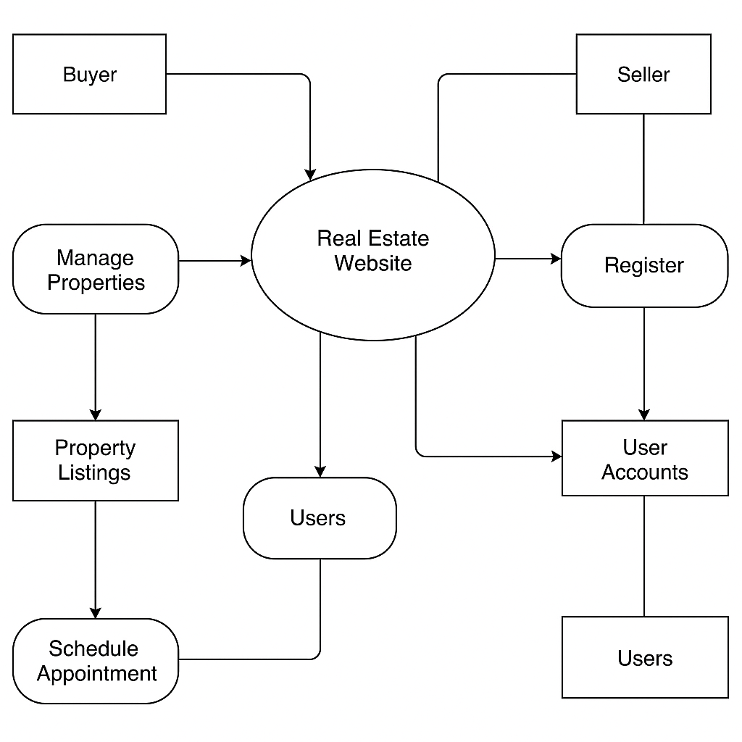

*Level 1 dfd*

*User management module*

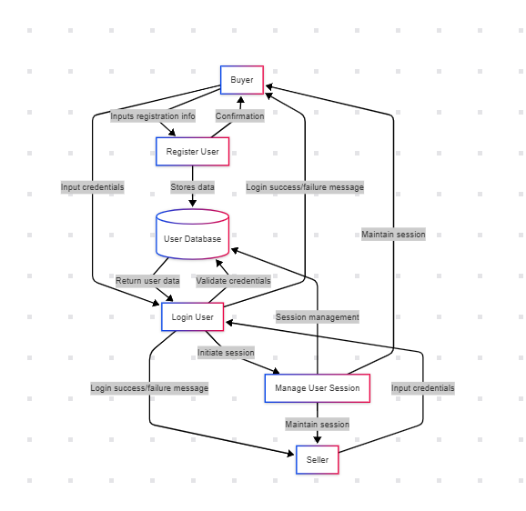

*Property Management module*

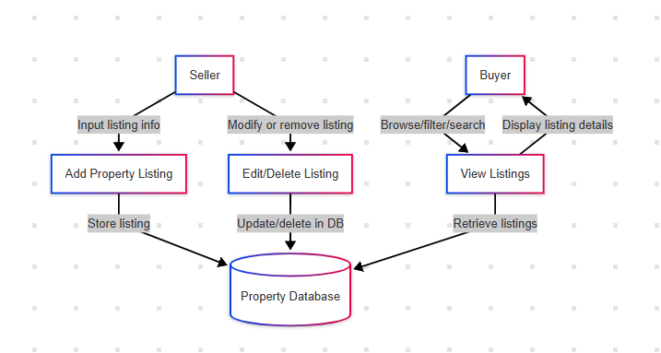

*Appointment scheduling module*

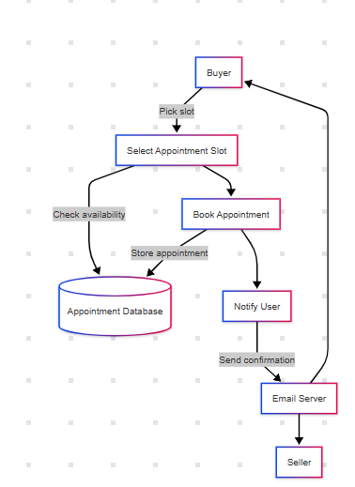

# A. Appendices

## Appendices provide additional resources and background information to support the SRS document. These do not form part of the formal requirements unless explicitly stated*.*

## A.1 Appendix 1

**Client Meeting Summary**

* Discussed roles: Buyer and Seller
* Required features: Listings, Appointment scheduling, Login system
* Tech Stack: HTML, Tailwind CSS, JS, PHP, MySQL
* Visual requirements: Clean, responsive UI with mobile-first design

## A.2 Appendix 2

**UI Mockups and Screens**

* Homepage

For buyer



For seller



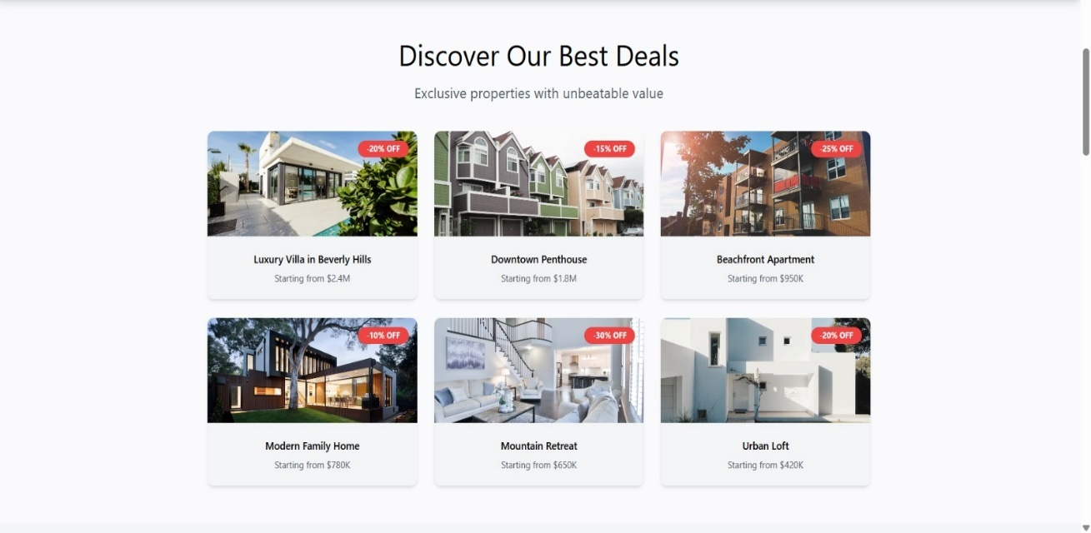

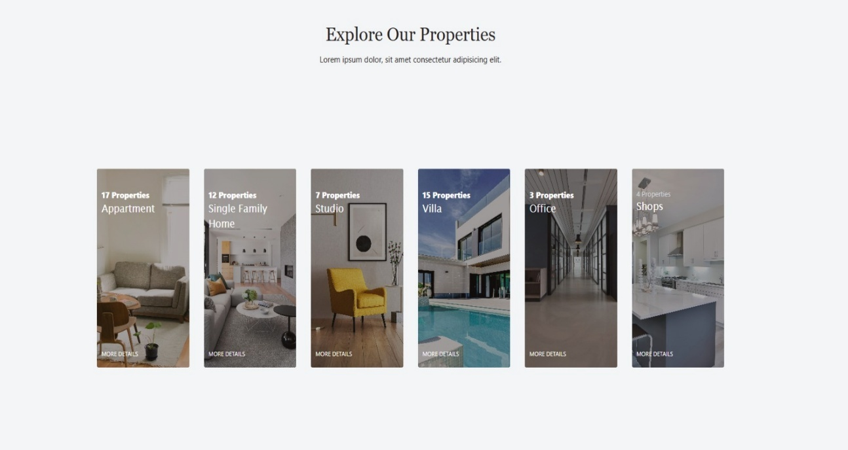

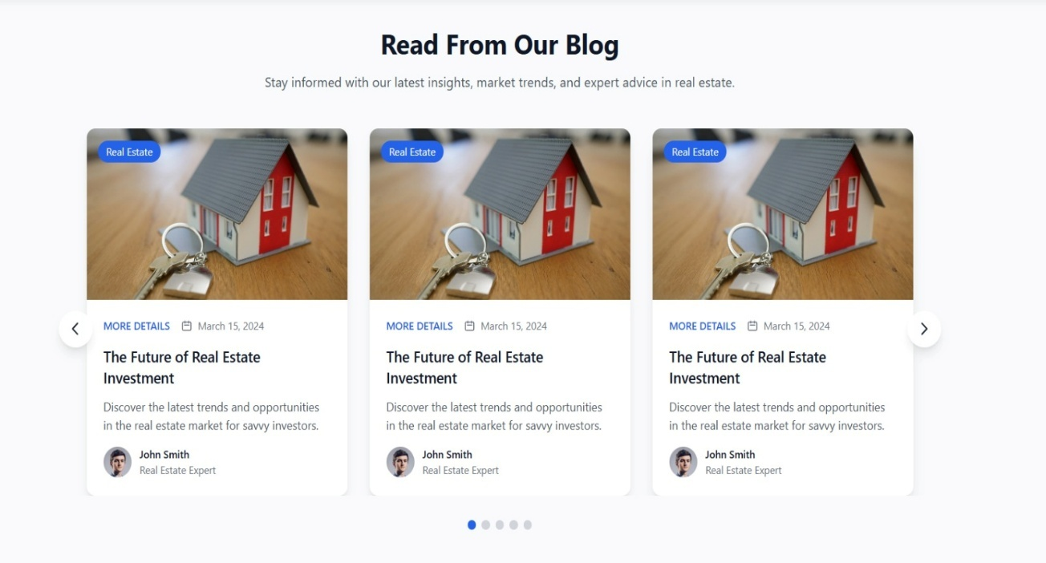



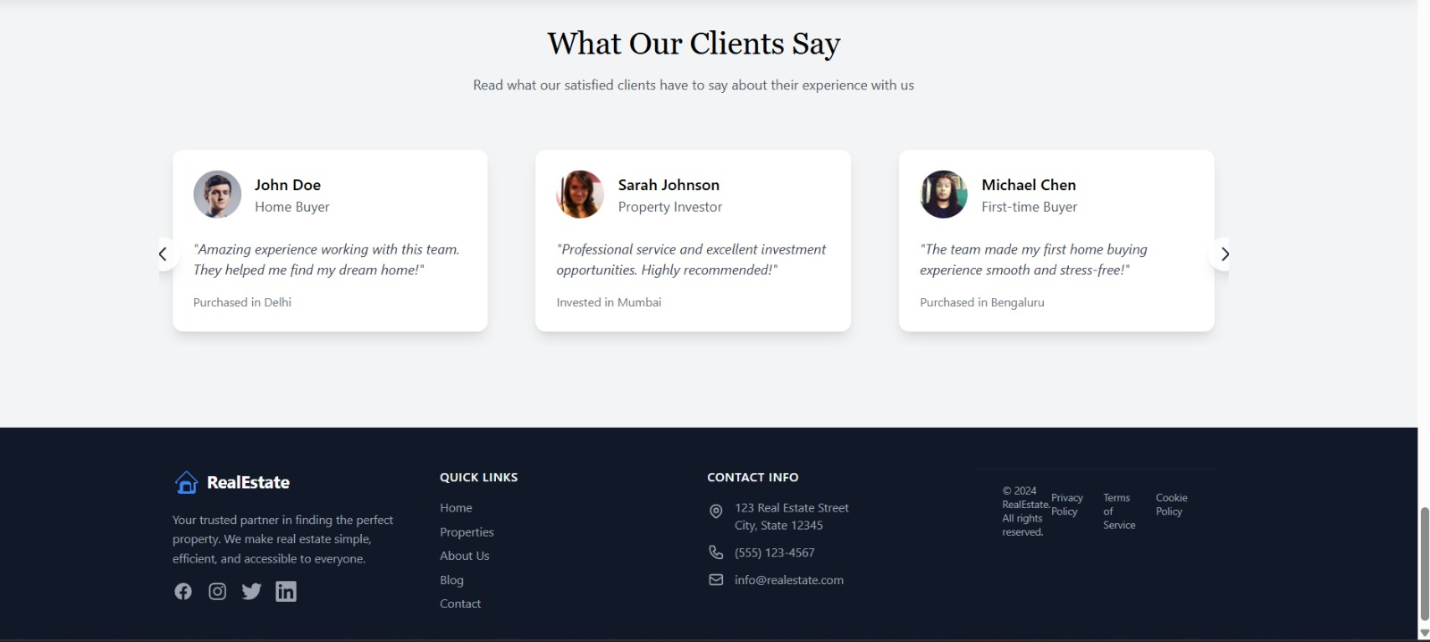

* Login/Register pages

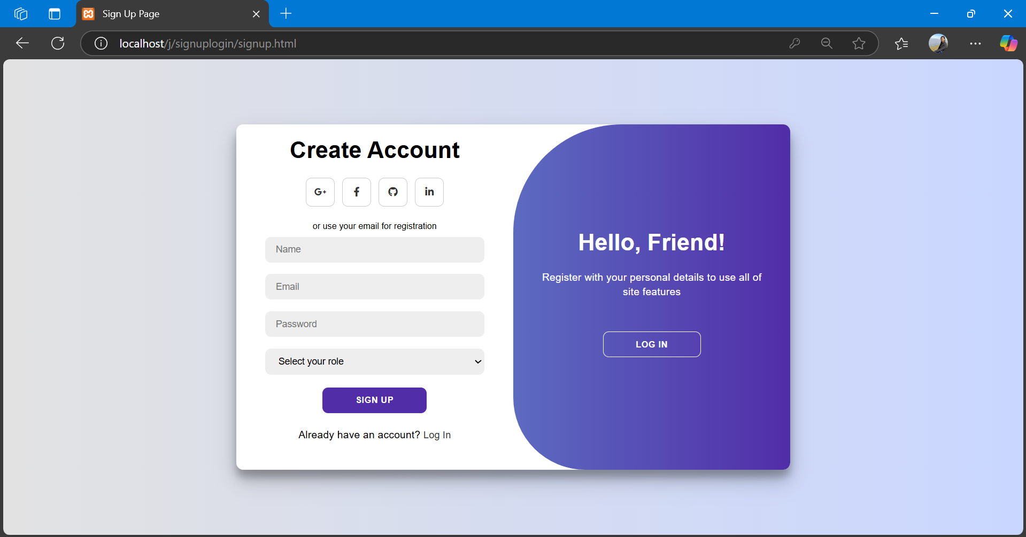

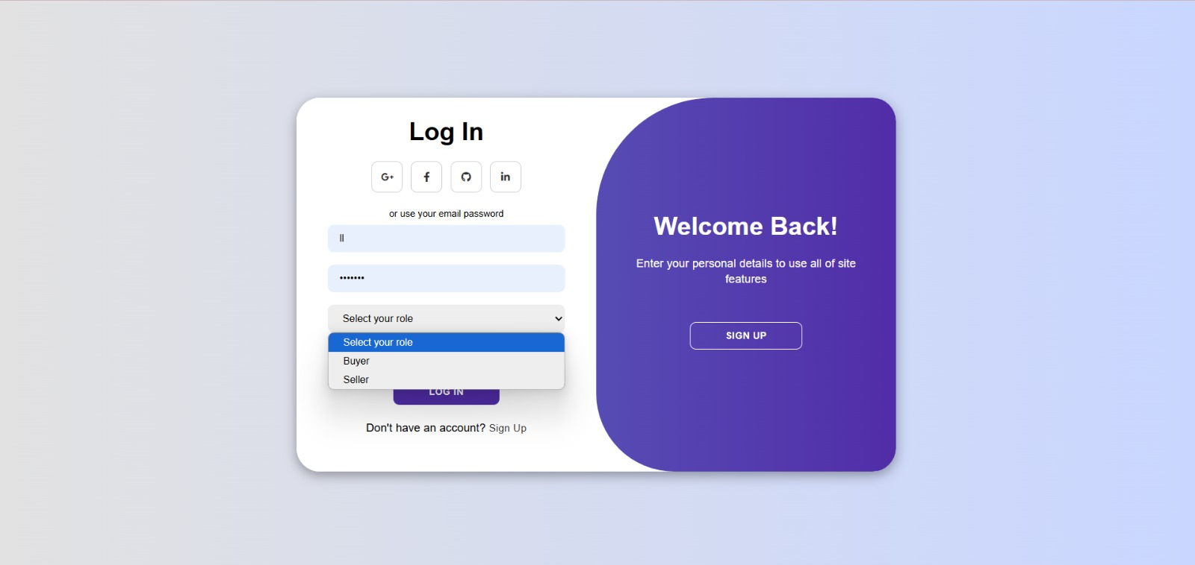

* Property detail page

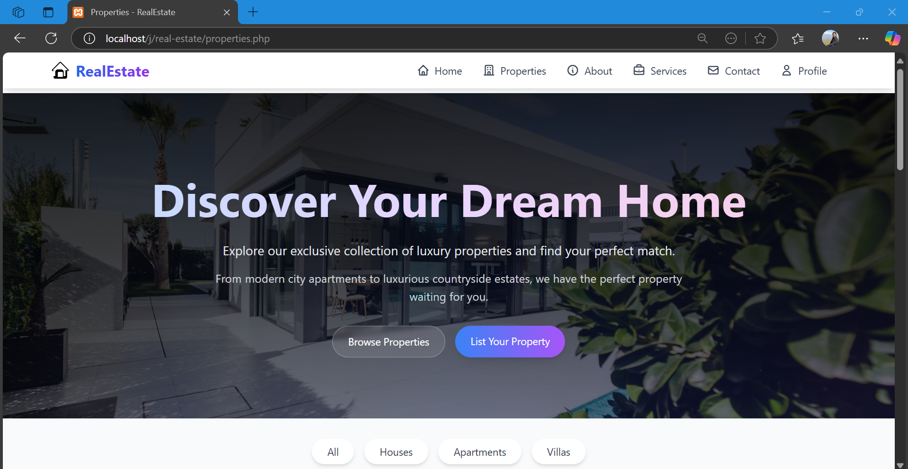

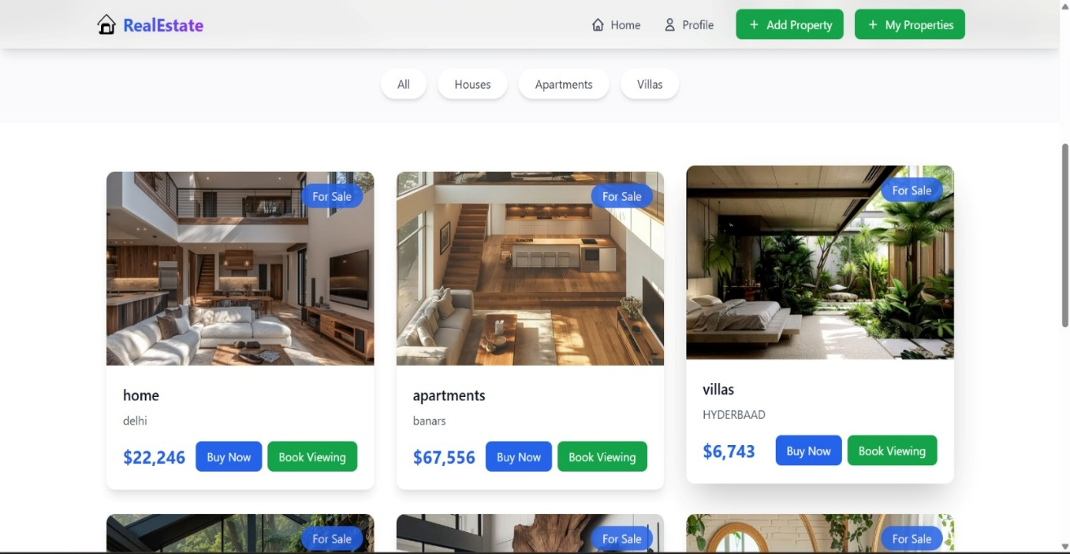

For seller

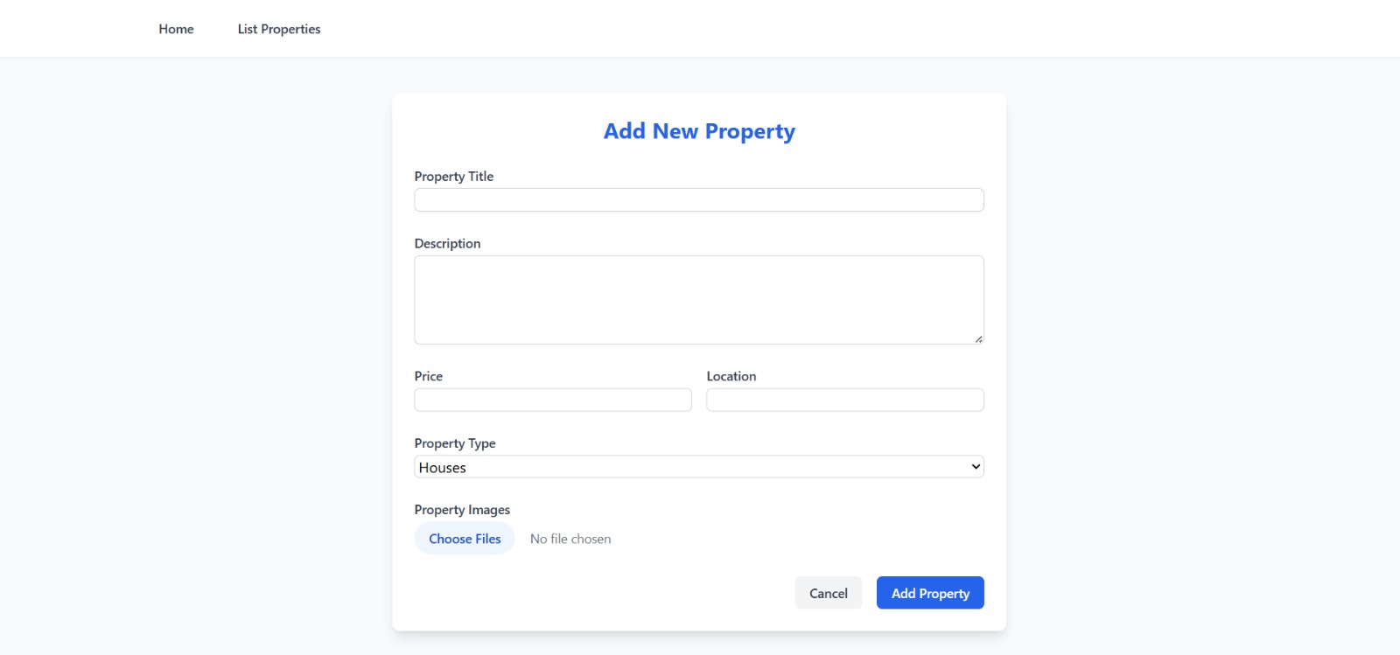

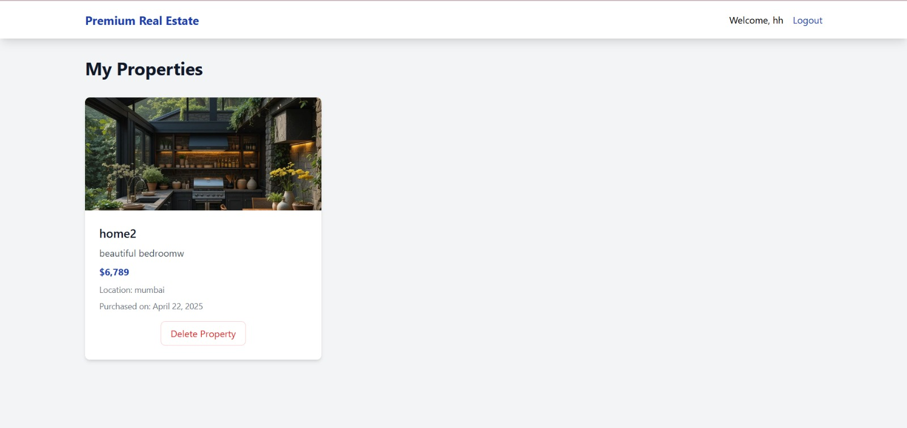

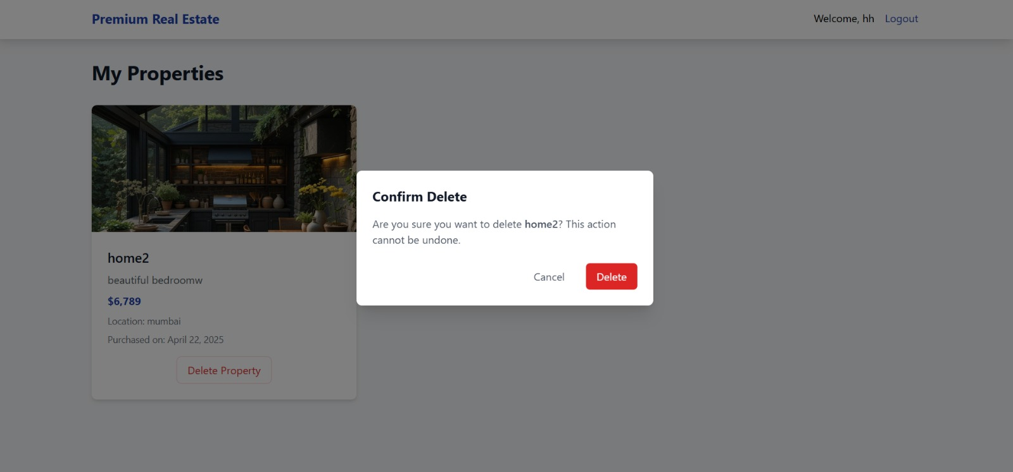

* Appointment form

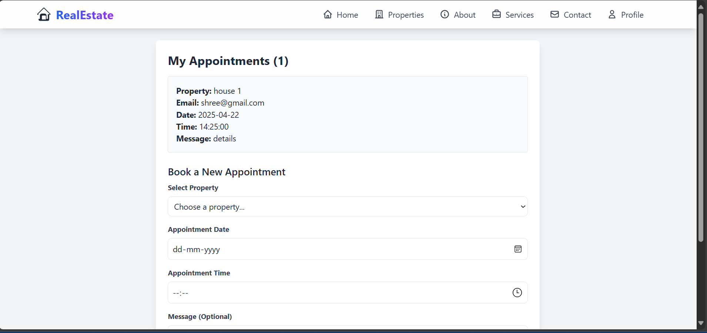

* Services

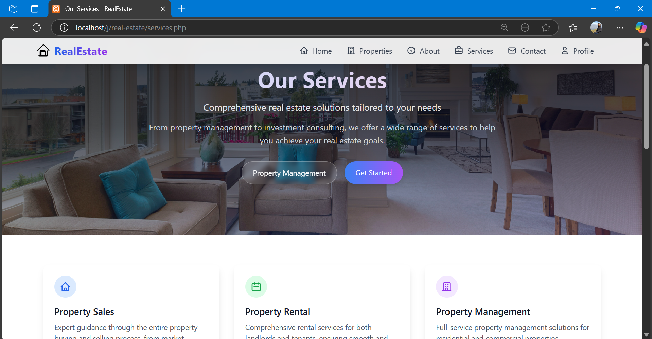

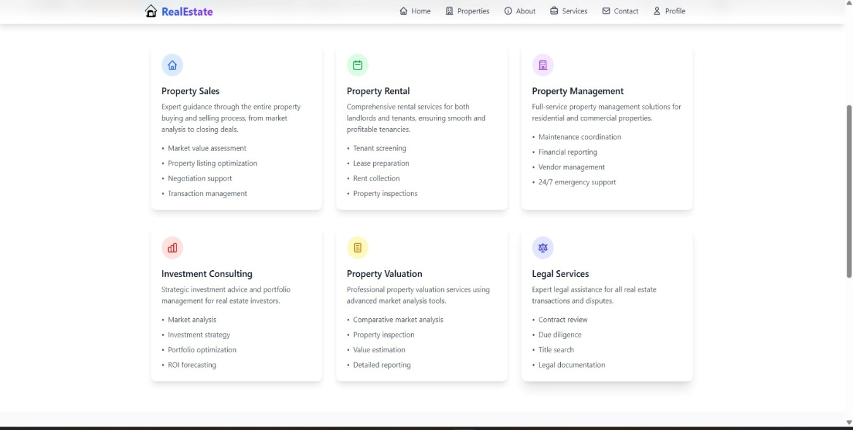

* **Contact**



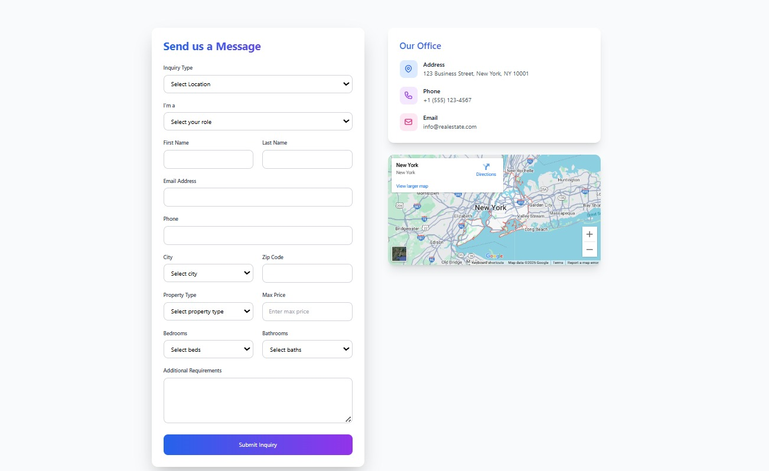

* **About us**



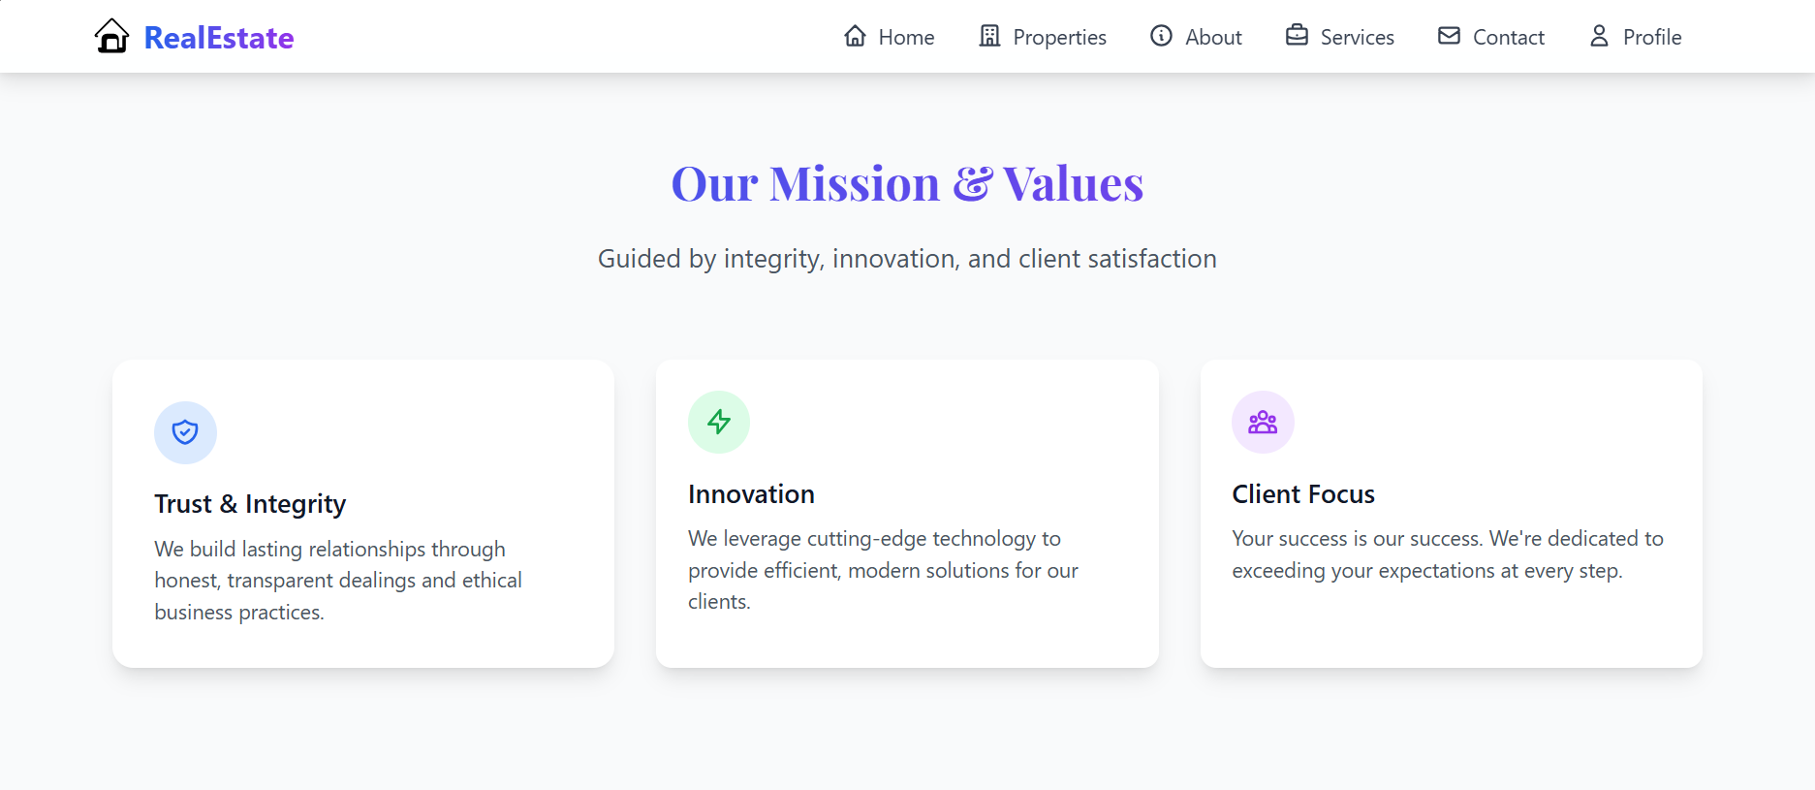

**A.3 Appendix 3**

**Tools Used**

* Design Tools: Figma (for mockups)
* Development Tools: VS Code, XAMPP
* Diagram Tools: Draw.io
* Database: MySQL Workbench